**TARGET**

**2013년 11월 3일 09시30분**

**Part 1**

Q1. The Cycle Shop is proud sponsor for health race this Saturday. Before Saturday, racers can stop by the store to complete the registration form, receive the participant’s number and pay the entrance fee. If you prefer to register on the day of the race, you can do so at the event location between seven and nine AM.

<http://cafe.naver.com/toeicspeakinginwm/551>

Q2. Thank you for using our automated banking system. We aim to deliver quick, convenient and reliable banking services. For your accounting information, please press “one”. For help with online and providing banking, please press “two”. If you require any additional assistance, please press “zero” to speak to one of our representatives.

**Part 2**

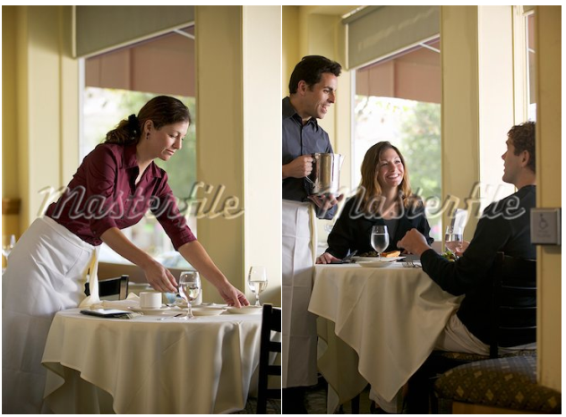

한가한 식당 안에, 테이블이 총 3개가 있음.

맨 앞 쪽에 흰 긴팔 티를 입은 여자가 테이블 옆에 서서 빈 테이블을 세팅하고 있고, 거기엔 4개의 의자가 놓여져 있고 꽃병이 놓여있다.

뒤엔 다른 테이블에 4명 중 3명이 등을 돌리고 앉아있고 옆에 웨이터 같이 생긴 남자가 쟁반을 들고 있는데 흰 색깔의 머그컵들이 보인다.

왼쪽으로는 검은색 피아노가 보이는데 옆에 한 남자가 앉아서 창 밖을 바라 보고 있다. 배경으로는 블라인드가 쳐져 있고 창 밖으로 풍성한 나무를 볼 수 있다.

흰 긴팔 티입고 a black apron을 입은 waitress 한명이 꽃병이 놓인 빈 테이블을 세팅하고 있고, 남자 웨이터(노란셔츠, black apron) 한명이 쟁반을 들고 물을 따르고 있는 동작이 보였습니다

뒤에는 손님이 창밖을 바라보고 있었습니다. 창너머로 나무도 보임.

This is a picture taken at a restaurant. In the foreground of the picture, I can see a woman who looks like a waitress. She is setting the table with a vase(꽃병). She is wearing a white long sleeved t-shirt and a black apron. Behind her, there are four people talking to each other. Next to them, a waiter is serving some water to the customers. On the left side of the picture, there is a piano. Next to it, a man is seeing outsides. It looks like people are having a great time at the restaurant. 45초 맞음

**Part 3.**

Imagine that a German marketing firm is doing a research about jobs. You have agreed to participate in a telephone interview about **junior high school life.**

Q4. When you were in junior high school, what subject did you spend time most?

Q5. Would you prefer to study alone or with other classmates when you were in junior high school?

Q6. Did you spend a lot of time on studying when you were in junior high school?

**Part 4.**

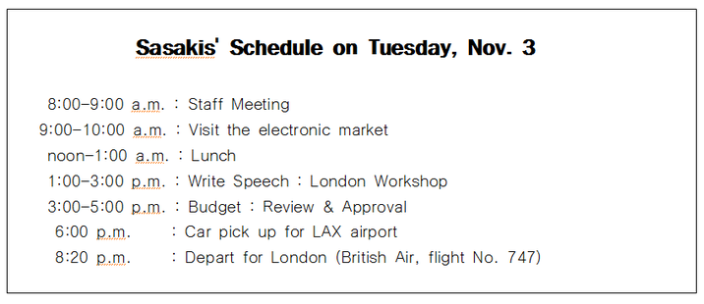

|  |  |
| --- | --- |
| **Free School Art Museum**  **Daily Schedule for Ken Sansaki, Director**  **Thursday, October 12th** | |
| 8:00~9:00am | Staff meeting with museum guides |
| 9:00~10:00am | Special tour: new photographic exhibit |
| 10:00~11:00am | Conference call: trustees |
| 1:00~3:00pm | Write speech: London conference |
| 3:00~4:00pm | Budget: review and approve |
| 5:50pm | Car service: pick up for airport |
| 8:50pm | Depart (Skysale flight 593) to London |

**Narration:** Hello, this is Ken Sasaki the director. I will have an important meeting in London soon and I got the schedule sheet but I lost it. Could you please answer some of my questions?

Q7. I will fly out to London on Thursday but I don’t have any detailed information. Could you please tell me my flight number and what time will I have a pick-up service?

Q8. I would like to have a staff meeting early in the morning. Is it possible to have the meeting at 9am?

Q9. I know that I will have a couple of things to do before I leave for London. What things are scheduled in the afternoon?

**Part 5**

Q10. Hello, this is Jenna Jane, the vice president. As you know, we will have our toy store’s 20th anniversary event next week. So we are planning to have some special activities for kids. We are expecting many parents visiting our store with their children but I am wondering what kind of activities attract parents. I want to market parents and hope to have a good time with their children when they visit us. Since you are experienced in marketing, I thought you would have some good ideas for this. Please call me back with your ideas. My extension number is 25. Thanks.

**Part 6**

Social Networking Websites allow people to connect each other and update pictures to share together.

Do you agree or disagree with the following statement:

Social Networking Website is wasting our time.

Give specific reasons and examples to support your opinion.

**TARGET**

11월 3일 13:30

**Part 1**

Q1. Even though it requires some efforts, making your house energy efficient is a great way to save money. Changing light bulb brands, sealing your windows, and unplugging appliances can all help you conserve energy. In fact, some home owners report 30% decrease in their monthly energy bill with these changes.

Q2. Thanks for listening to the Regional Book Club radio program. Today in the studio, we have acclaimed novelist, Mathew Clark who will be talking about his latest book. Following our discussion, he will be taking questions from our listeners. Please call, send an email, or text your questions to us anytime during the program.

**Part 2**

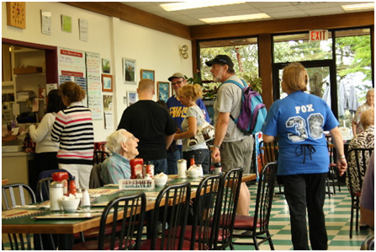

커피숍에 다섯 명의 고객과 점원이 나온 사진. (고객은 두 그룹으로 나뉘어져 있음.)

**왼쪽**에는 노란색 컵을 들고 응시하는 남자와 메뉴판을 보고 있는 여자가 보임.

**그 옆으로**는 두 명의 남자와 한 명의 여자가 보이는데, 여자는 앞에 있는 점원으로부터 컵을 전달받으려 하고 있음. 점원은 흰색 블라우스에 검정색 정장바지 차림이었으며, 두 개의 하얀 머그컵을 고객에게 전달하고 있음.  **전체적으로 파이프 구조의 건물 안에서 찍힌 사진이었으며, 뒷편으로는 창문을 통해 맑고 화창한 날씨가 보임.**

**This is a picture taken at a café. On the left side of the picture, I can see two man and one woman. She is receiving a cup from a clerk. The clerk is wearing a white blouse and black jean and handing over a white cup to the customer. The weather is sunny, because I can see blue sky through the window.**

**Part 3.**

Imagine that a National Tourism Bureau is doing research in your area. You have agreed to participate in a telephone interview about **visiting parks.**

Q4. What is your favorite park since you were a child, and how far is it?

When I was in child, my favorite park was near my school, it was very close to my house.

Q5. Do you go to parks more often now than you were a child? Why or why not?

Q6. What things should be improved for children to make the parks better in your area?

**Part 4.**

|  |  |  |  |  |  |  |  |  |  |  |  |  |  |  |  |  |  |  |  |  |  |  |  |  |  |  |  |  |  |  |  |  |  |  |  |  |  |  |  |  |  |  |  |  |
| --- | --- | --- | --- | --- | --- | --- | --- | --- | --- | --- | --- | --- | --- | --- | --- | --- | --- | --- | --- | --- | --- | --- | --- | --- | --- | --- | --- | --- | --- | --- | --- | --- | --- | --- | --- | --- | --- | --- | --- | --- | --- | --- | --- | --- |
| **ABC Laboratories Human Resources Department**  **Job interview Schedule – Thursday December 10**     |  |  |  |  | | --- | --- | --- | --- | | Time | Applicant | | Open Position | | 9:30 a.m. | Gilbert Monroe | | Research Assistant | | 10:15 a.m. | Melanie Simpson | | Administrative Assistant | | 11:00 a.m. | Armor Khan | | Web Technician | | 1:00 p.m. | Downy Miller | | Assistant | | ~~1:45 p.m.~~ | ~~Carlos Romeo~~ | | ~~Administrative Assistant~~**~~Cancelled~~** | | 2:30 p.m. | Christopher Wang | | Research Assistant | | 3:15 p.m. | Sandy Barkley | | Sanitation Supervisor | | 4:00 p.m. | Denise Hunter | | Research Assistant | |  | |  | | |  |  |  |  | |

**Narration:** Hi, this is Hardy, and I will interview some of applicants tomorrow but I lost my interview schedule sheet, so I am wondering if you could answer some of my questions.

Q7. What date will the job interview be held?

The job interview will be held on Thursday December 10th.

Q8. I think I have an appointment with my friends around 1:45p.m. Would it be a problem?

Q9. Could you give me the details of applicants who applied for research assistant position?

**Part 5**

***Respond as if you are a Dan’s assistant***

Q10. Hi this is Dan, the owner of the company. Since you are **my assistant**, I need your help. I just received new uniforms I ordered and found out that, on the uniforms, our company name was spelled incorrectly. They said they made a mistake but unfortunately it will take two more weeks to get the new uniforms. The problem is we will host a banquet **this weekend** and we need new uniforms. **Otherwise**, we have to wear old uniforms that are old-fashioned. Also, some of old uniforms are worn out. I want my team look professional to our guests, but the new uniforms have **misspelled** company name. What should we do to solve this **problem**? Should we wear old ones or the new ones with incorrect names on it? I want you to come up with solutions as soon as possible. Please get back to me at extension 3449. Thank you.

**Part 6**

Q11. Do you agree or disagree with the following statement? *“Stores should reward customers for purchasing environmentally friendly products.“*Give specific reasons and examples to support your opinion.

**TARGET**

11월 10일 10:30

**Part 1**

Q1. Thank you for calling Dexter shipping and delivery. The source for all your shipping needs, please listen carefully to the following options. For package tracking information, please press one. For more information on shipping rates, delivery times, and store locations, please press two. If you’d like to speak with a customer service representative, please press three.

Q2. Good afternoon and welcome to the Springfield walking tour. We are so glad to have you with us today. On today’s tour, you will learn more about the fascinating history of this wonderful town. We will be visiting history buildings, famous monuments, and the beautiful city park. Unless you have any questions, we are ready to get started.

**Part 2**

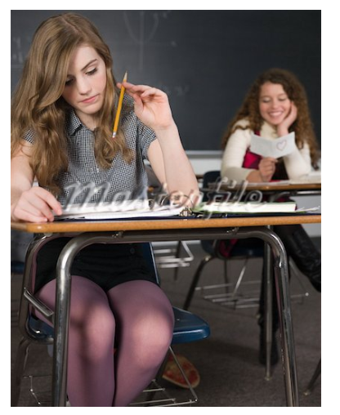

**<두 명의 여학생이 교실에서 찍힌 사진>**

정 중앙에 (중학생 정도로 보이는) 두 명의 Asian여학생들이 갈색 책상에 앉아있음

**왼쪽 여학생**은 검정색 티셔츠를 입고, 검은 머리를 묶고 있었으며, 오른쪽 여학생을 보고 있었음. (학생 앞에 있는 책상에는 노트와 필통이 놓여있음)

**오른쪽 여학생**은 빨간색 티셔츠를 입고 왼쪽의 여학생과 이야기를 하고 있었음. (그녀 앞에 있는 책상에는 책과 메모가 된 종이, 물병이 놓여있음)

뒷 배경 – 그들 뒤로 몇 개의 책상이 더 있음

– 왼쪽 벽에는 그림과 알림 포스터가 여러 개 붙어있음

– 뒤쪽으로 흰 블라인드가 쳐져 있음

This is a picture taken in a classroom. There are two students in this picture. Both of them are sitting at a desk. There are some stuffs on the desks. They are talking to each other. A girl on the left is wearing black t-shirt and has black hair. She is looking at her a classmate on the left. Next to her, there is a girl wearing red t-shirt. Behind them, there are some desks. On the left side of the picture, there are some pictures and posters posted on the wall. In the background of the picture, I can see stretched white blinds.

**Part 3.**

Imagine that an US Marketing Firm is doing research in your country. You have agreed to participate in a telephone interview about **news sources.**

Q4. Are you more interested in local or national news? And why?

Q5. What are some different ways you can get news in your country?

Q6. Which of the following ways do you prefer to get news? And why?

-      Television / Radio / Printed newspaper

**Part 4.**

|  |  |
| --- | --- |
| **Mark Holmes**  **Head of Alborn Business School**  **Schedule for Monday, April12** | |
| 9:00AM~10:00AM | **Faculty meeting** |
| 10:00 AM~11:00AM | Finalize plans for upcoming school year |
| 11:00AM~12:00PM | ~~Conference call - Review budget report~~  Moved to Tuesday |
| Noon ~1:00PM | Lunch with David Shaw (Head librarian) |
| 1:00PM~2:00PM | Interview: Isabel Hernandez  (Financial professor position) |
| 2:00PM~3:30PM | Discuss building plans (Apple architecture firm) |

**Narration:** Hello. This is Mark Holmes. I already got off work. I left the schedule list on my desk. Since you are my assistant, please check my schedule for tomorrow.

Q7. What time does my first schedule start, and what is it?

Q8. I know I have a conference call regarding the review of the budget report. Could you tell me what time does it start?

Q9. Could you tell me all the details of the schedules after lunch?

**Part 5**

Q10. Hi, this is Carson, the manager calling for the delivery supervisor. And here‘s good news for you. As you know, our delivery truck is old and breaks down a lot. The owner has decided to buy a new truck, but we need to decide what kind of truck we should get. We have two options. Although an electronic hydrogen truck is more expensive, it costs less for fuel. On the other hand, we can buy a gasoline power truck, which is cheaper than electronic hydrogen truck although it costs more for fuel. Which do you think is better and why? Please call me and give me your opinion because I need to explain to the owner which one is better as soon as possible. Again, this is Carson at extension 525.

**Part 6**

Some people prefer to keep in touch with their friends by using Social networking websites. On the other hand, others prefer telephone conversations. Which do you prefer and why? Give specific reasons and examples to support your opinion.

**TARGET**

**2013년 12월 1일9시30분**

**Part1**

Q1. Join us for a tour of Kansas City and see all of the area’s major landmarks. First, we will visit the Town center monument, Cornwall tower, and Shelton Building. To complete the tour, we will stop at the historic Montgomery Plaza where you can find a variety of restaurants to choose from for lunch.

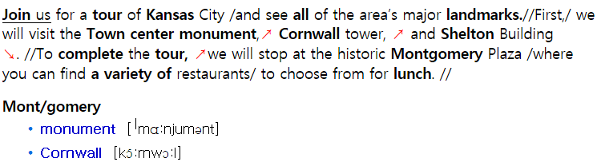

Q2. Commuters will probably have a long morning today. Because downtown electricity lines are under construction, several roads are closed. Main Street, Market Street and Bakery Avenue will be closed to the traffic for the rest of the week. Next week, the situation will improve with the completion of repairs.

**Part2**

**<기념품 점에서 찍힌 사진>**

세부 사항 – 기념품점 바깥에서5명의사람들이보임.

오른쪽엔 두 여자가조각상을살펴보고있으며둘 다 금발이었다.

가운데는 두 여자가배낭을맨 채 대화를하고있음.왼쪽의한 남자는왼쪽방향으로걸어가고있으며주황색폴로셔츠를입고있다.

가게 안을 통해여러가지진열된제품들이보인다.

This is a picture taken in front of a gift shop. There are five people in this picture. On the right side of the picture, there are two women looking at a statue. They have blond hair. In the middle of the picture, there are two women talking to each other and carrying a bag. On the left side of the picture, a man is passing by and wearing a orange polo shirt. I can see a variety of displayed items in the store.

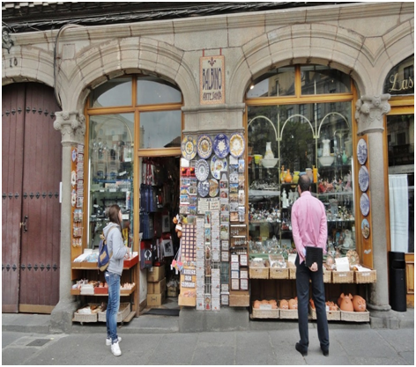

|  |
| --- |
|  |

**Part3.**

Imagine that an Australian life style magazine is doing a research in your area. You have agreed to participate in a telephone interview about lunch**.**

Q4. What time do you usually have lunch and who do you usually eat with?

Q5. What kinds of food are common for lunch in your country?

Q6. What are some factors you would consider when you choose a restaurant for lunch?

**Part4.**

|  |  |
| --- | --- |
| **Insight Publishing**  New Employee Orientation Session  Friday, May 22nd | |
| 9:00 ~ 9:15 am | Welcome speech (Ricky Harrison, CEO) |
| 9:15 ~ 10:00 am | Overview of the company and its operations |
| 10:00 ~ 11:00 am | ~~Photos for identification badges~~  (Rescheduled for Tuesday) |
| 11:00 ~ 12:00 am | Company tour 1 : Digital content team, Editorial department |
| 12:00 ~ 1:00 pm | Lunch |
| 1:00 ~ 2:00 pm | Presentation : Publishing Procedures   (Joshua Hann, Executive Editor) |
| 2:00 ~ 3:00 pm | Company tour 2 : Marketing department, Printing area |
| 3:00 ~ 4:00 pm | Meeting with manager |

**Narration:** Hello. This is Kirk Hamilton, the head of human resources. I understand you’re scheduling next week intern orientation session. And I have a few questions about it.

Q7. Who is going to give the welcoming speech and what time does it begin?

Q8. I remember seeing our executive editor’s name on the schedule. What is he going to do?

Q9. Can you give me the details of the schedule after lunch?

**Part5**

Q10. Hi, this is Matthew Woods, the manager of Square Food Market. Since you are the store owner, I’d like some advice about preparing for the upcoming event. The city is going to host a music festival soon and thousands of people are expected to attend. The Festival will be held in the park right across the street from our store. Since there aren’t many other stores nearby, I’m sure we’ll get a lot of customers during the event. However, our store is small, and I think we should prepare in advance to avoid problems like empty shelves or long lines at the checkout. Could you let me know what I should do to prepare for the large crowds? Again, this is Matthew. Thank you.

<http://cafe.naver.com/toeicspeakinginwm/551> -->음성

**Part6**

Q11. Do you agree or disagree with the following statement? “Nowadays, online advertising has bigger influences on people than advertisements on TV.” Give specific reasons and examples to support your opinion.

**TARGET**

12월 1일 10:30

part 2 Describe a picture

Q)3

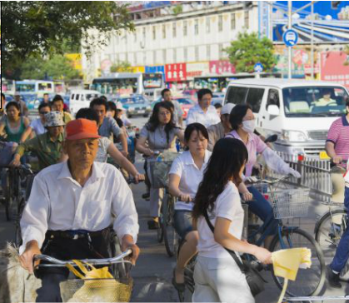

This is a picture taken on a street. There are many people in this picture. There is a group of people riding a bicycle. All of them are wearing light casual clothes. I can see some people in a store. In front of the store, some people are passing by. On the right side of the picture, some people are standing and talking to each other. On the left, I can see many buildings with signboards. In the background, there is a big building standing. Overall, it looks like this street is very busy with many people and cars.도로에 걸어다니는 사람과 자건거 타는 사람들, 왼쪽에 건물,

오른쪽에는 건물과 도로에 오토바이타는 사람, 뒷쪽에는 큰빌딩

도로에 걸어다니는 사람과 자건거 타는 사람들, 왼쪽에 건물,

오른쪽에는 건물과 도로에 오토바이타는 사람, 뒷쪽에는 큰빌딩

도로에 걸어다니는 사람과 자건거 타는 사람들, 왼쪽에 건물,

오른쪽에는 건물과 도로에 오토바이타는 사람, 뒷쪽에는 큰빌딩

Part 3 Respond to questions

(free time activities) : 취미활동

Q)4. What do you do in your free time and have you talked to your family members about your hobby?

Q)5. Do you like to talk about your hobby with friends? Why?

Q)6. Are you planning to do activities that you haven't experienced before? Why or why not?

Part 4 Respond to questions with the information provided

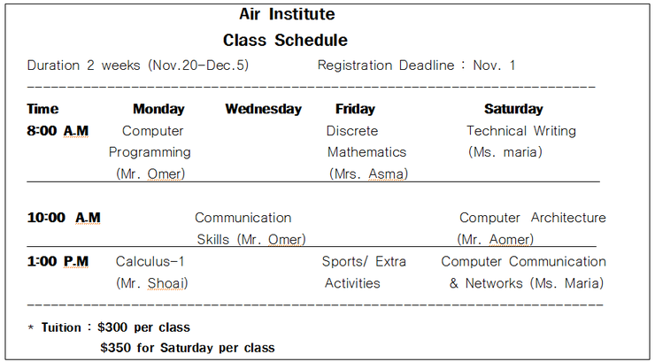

Q)7. When do the courses start and until when do I have to register?

Q)8. I will be attending Saturday courses, I heard that the tuition is 300 dollars, am I right?

Q)9. Could you tell me the classes related to a computer course?

Part 5. Propose a solution

Hi, this is ______ the manager from Mufflin Hotel. I am calling you to ask your advice. We recently got a lot of complaint about restaurant. They filed huge amount of complaint on restaurants that we don't have in our hotel. We don't have a choice but to open a restaurant sometime soon. The problem is that we haven't decided which restaurant is good for our hotel. I am thinking one that is luxury and fancy so we can provide a nice environment to our customers. The other is a normal and casual restaurant for family who visits our hotel most. Which restaurant do you think better for us to open in our hotel?

Part 6. Express your opinion

Q)11.

Do you prefer to work for a small company or a big company?

Use specific ideas and examples to support your opinion.